Et-talibi Kamal

Dr. Jawhari Saida

[Class Name]

[Date]

The Influence of Computer Science on Language Shift.

Case: computer science learners and IT professionals

Ibn Zohr University Agadir Morocco.

**Introduction**

# 

# 

# **Part 2: Empirical part**

**1. Data Collection**

In May 2022, we started carrying out the main study at the Department of English studies at Ibn Zohr University as well as in a vocational school for that provide professional training in computer science and information technology in Agadir city. For the vocational school, we personally met trainees in order to ask about the availability and willingness of our chosen sample and for any clarity regarding our research and questions if they are required, since the cooperation of the sample is necessary and healthy for any research.

**1.1 Methodology**

This section of the study covers the methodology of research, sampling, population and tools used in the study and procedure of analysis. We have discussed all these elements briefly to provide a clear picture of the process of need analysis.

**1.2 Population**

We have selected students of semesters 4 and 6 of the English studies Department from Ibn Zohr University, in Morocco as well as trainees in a computer science vocational training school in Agadir city in Morocco, as the population for our research as our study revolves around the influence of learning computer science and information technology in shifting student’s language.

**1.3 Tools**

As this study is a qualitative study, the tool that we have selected for collecting the data is questionnaires, using online surveys, because they are relatively easy to prepare, they obtain information that is relatively easy to tabulate and analyze. We made sure that the students answered all the questions deliberately and honestly within the given time. These questionnaires are represented in 2 parts. The first part aims at collecting general information about the students e.g. age, gender, and educational level, university. The second part aims at investigating the attitude and thought students have about the relationship between English and computer science and information technology.

**1.4 Procedure**

After getting the questionnaires filled by 26 informants we started analyzing the data following the strategy of analyzing each question separately one by one. We have taken percentages based on the number of informants selecting the same answer choice of the question. By the use of online tools, we have got automatically the percentages calculated and we have interpreted the responses to express the needs, aims, attitudes, and beliefs of students. For making the responses more clear we have used the pie graphs and column bar graphs for simplifying the view which can be seen in the next section of the data analysis.

**2. Data Analysis**

The first part of our questionnaire aims to collect personal information about informants. According to the data, it is clear that both females and males are involved, 14 females and 12 males. As long as the age is included, 61.5% of students are between 19 and 21 years old, 3.8% under 18, and 34% above 25 years old. About the educational level, 88.5% are university students, and 11.5% are vocational training school students. Informants were also asked to include their institutions, 88.5% are in Ibn Zohr University of Agadir, 3% percent of students are studying in author universities. In addition, 80% of students are studying computer science, and 19% percent are not involved in any computer science program as the time of this study.

**Question 1: How do you study computer science?**

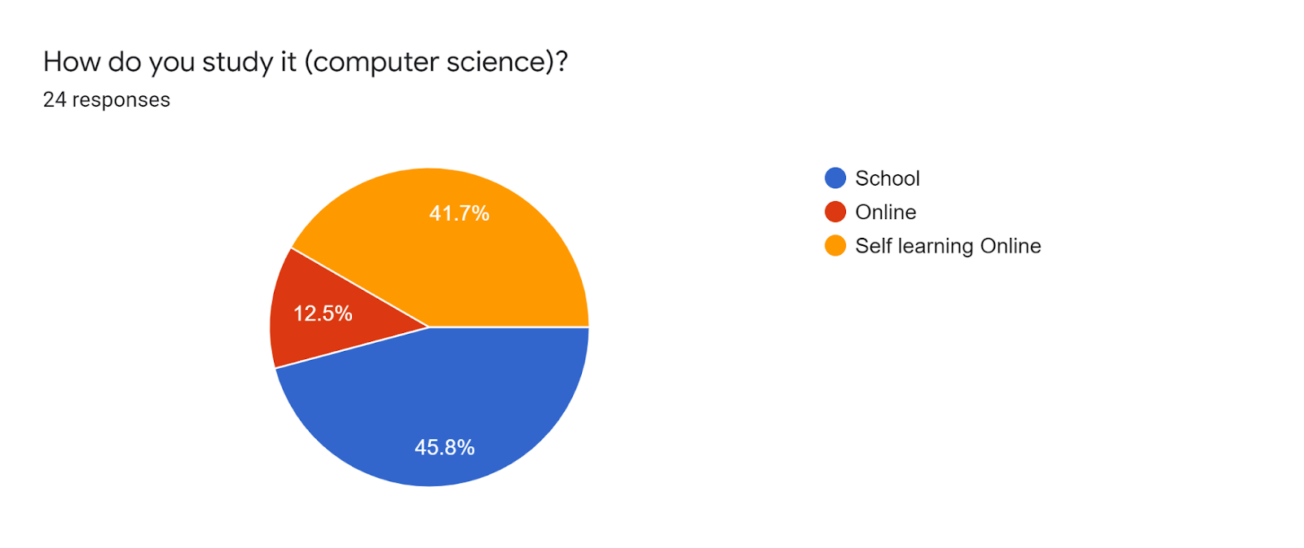

According to these results 45% of 24 students, are studying computer science in school which means they are attending classes whereas 41% of students are self-learners which refers to that they are learning computer science technologies and disciplines using the free online courses that are available on the internet, whereas 12.5% of students are involved in an online program or course. We can conclude that most of the informants have a computer science background and they are in one way or another interested in the field.

**Question 2: Do you need to know English as a software developer?**

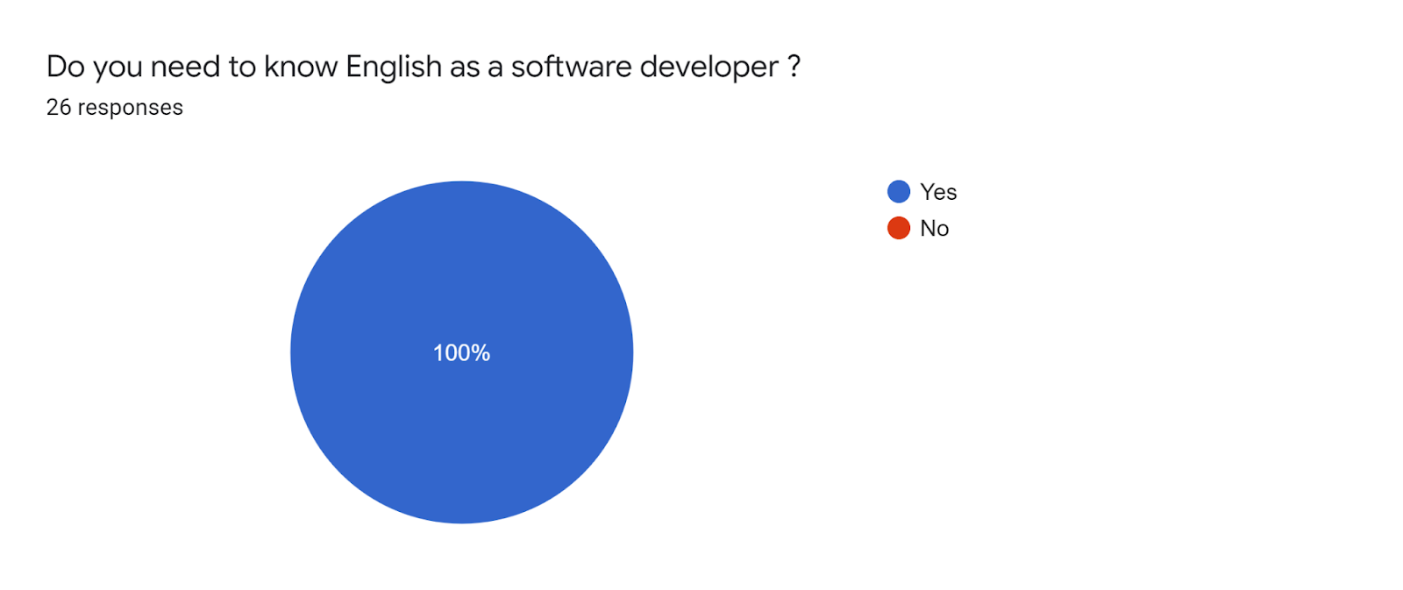

According to the results, 100% of all the 26 students respond with a positive answer, meaning that they all believe that English language skills are necessary for a software developer. Software development is a branch of computer science (Chapter 3 section 2). So we can say that this conviction can be a strong motivator for students to learn English and shift their focus to it more than other languages.

**Question 3: Do you think English language skills will help you in your career?**

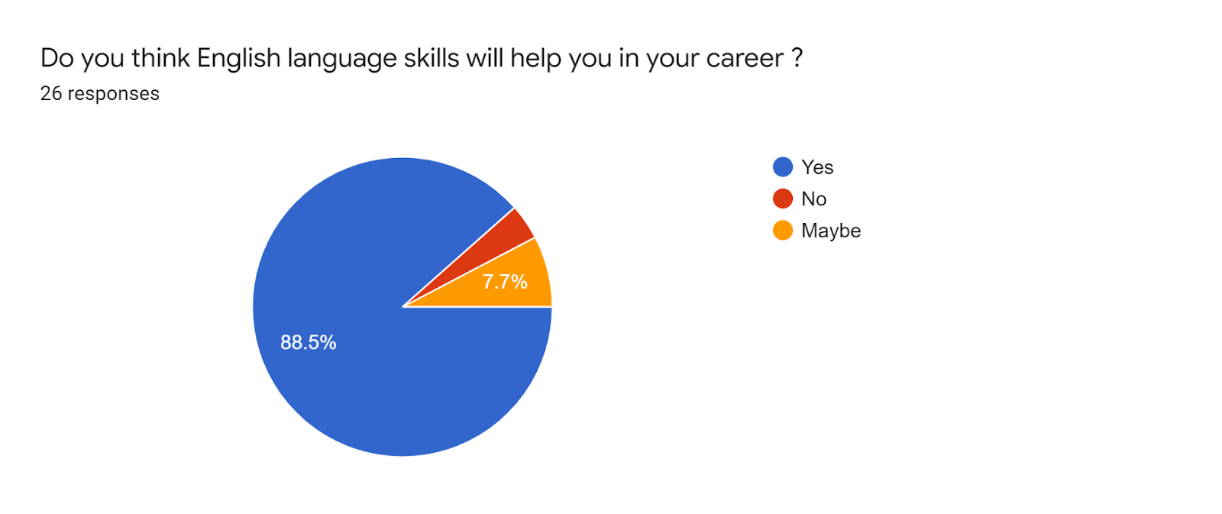

The result shows that 88.5% of students say yes, while 7.7% say maybe, and 3.8% said no. which means 23 people agree that the English language is important for perusing a successful career in the field of computer science and Information technology. From these results, we can conclude that socioeconomic factors can play a huge role in the dominance of a language. The social and economic factors are always responsible for shifting language in a society, which occur because members of a society tend to use the language that is more prestigious and powerful in a working domain. (Chapter 1, Section1).

**Question 4: What language do you use to search in Google for Coding Errors?**

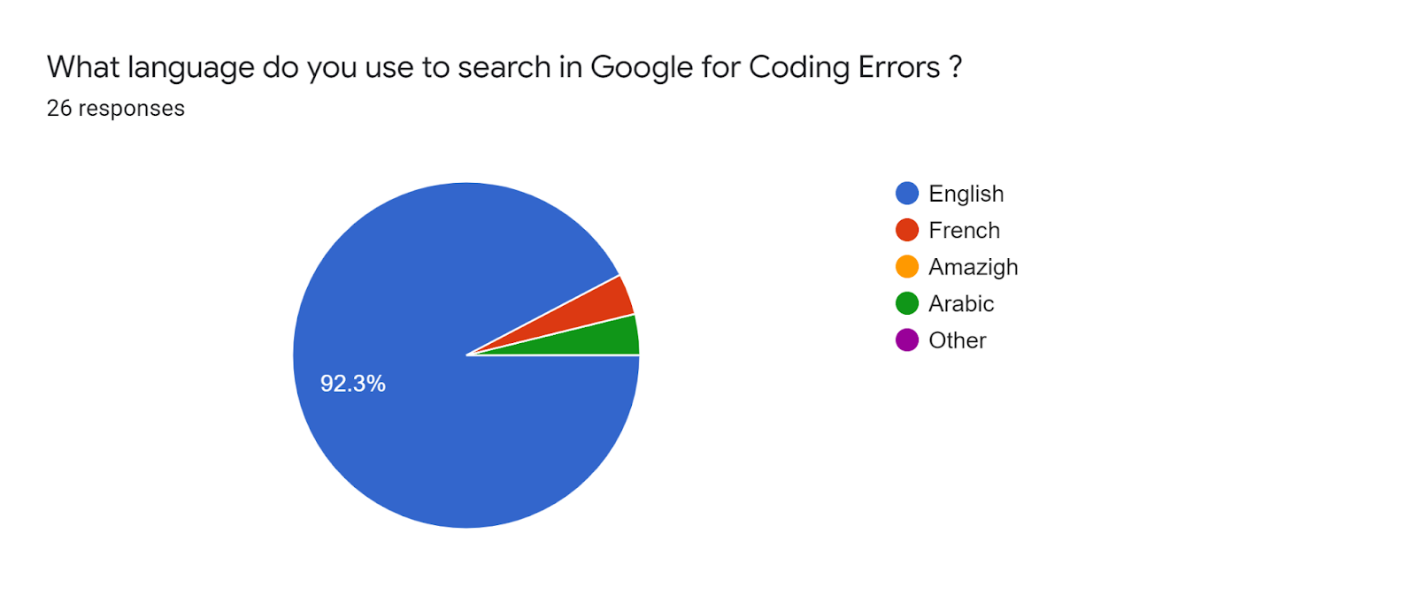

The result shows that 92% of students use English for errors solution searching in google, while 3% use Arabic and also 3% use French. As the graph also displays there are no students who use Amazigh or other languages. The result indicates that 24 of 26 students use English when they face errors in Information technologies for instance when programming or dealing with information systems. We can say that most of the computer science documentation and resources that is available only in English, can be the reason why most of the informants prefer to use English. Again this can lead to enhancing students English skills.

**Question 5: Computer science and Information Technology help you to learn new English vocabulary?**

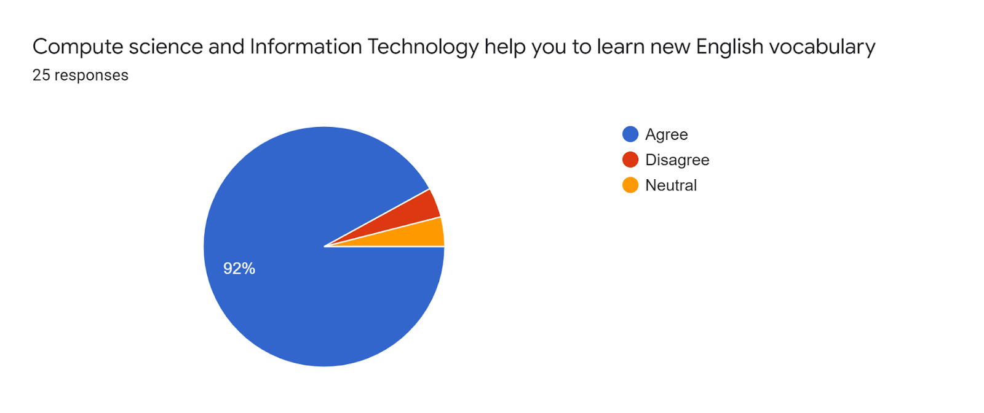

According to the results, 92% agree that studying computer science can help to learn new English vocabulary, only 4% said no and 4% are neutral. Meaning that 23 students support the idea that learning information technology and computer science disciplines can lead to acquiring more English vocabulary. These results show that studying computer science will lead to enhancing students linguistic repertoire of English.

**Question 5: what field you are more interested in computer science?**

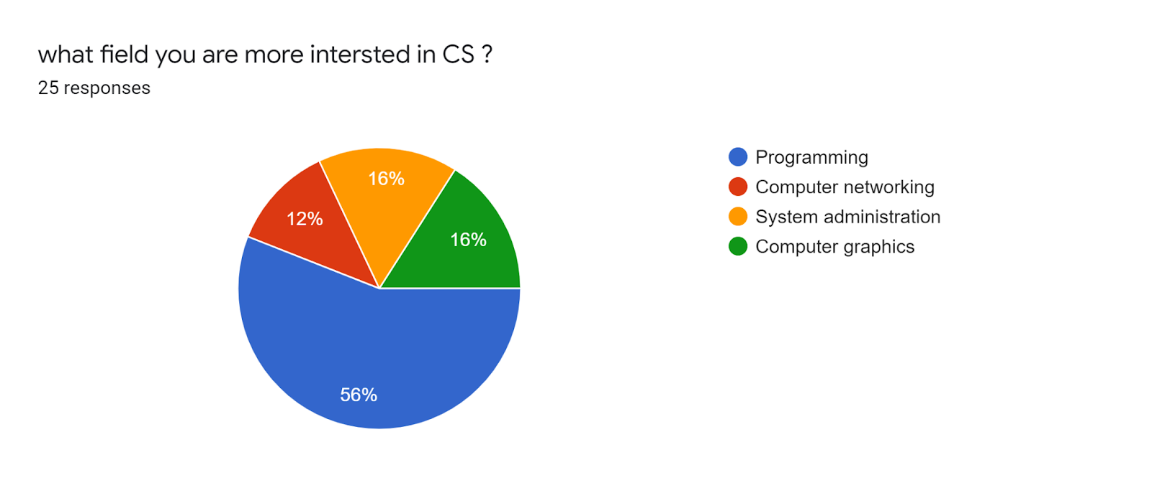

According to these 25 responses, 56% of students prefer computer programming, 16% are interested in computer graphics, 16% are interested in system administration, and 12% prefer computer networking. We can say that most students are attracted to software development like developing digital applications and graphics.

**Question 6: Do you need to learn English to get a good salary in Computer science or IT?**

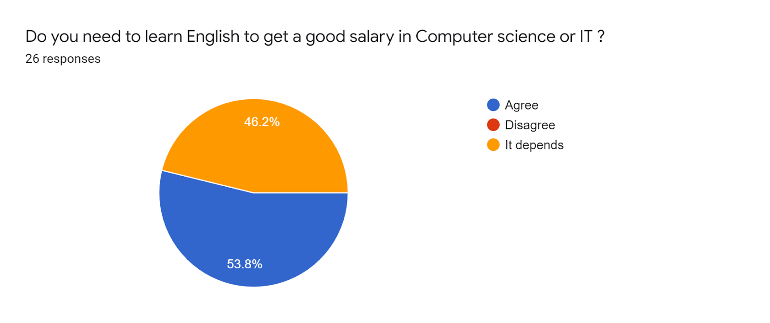

According to these results, 53% of students agree that learning English will help them get a good salary or income in their information technology career, while 46.2% said it depends. These results show that students aware of the necessity of English languages skills in the market and even those who say it depends it may be that they think computer science technical skills are more valuable than English language skills.

**Question 7: Are you going to travel to another country if you have found a job with better salary?**

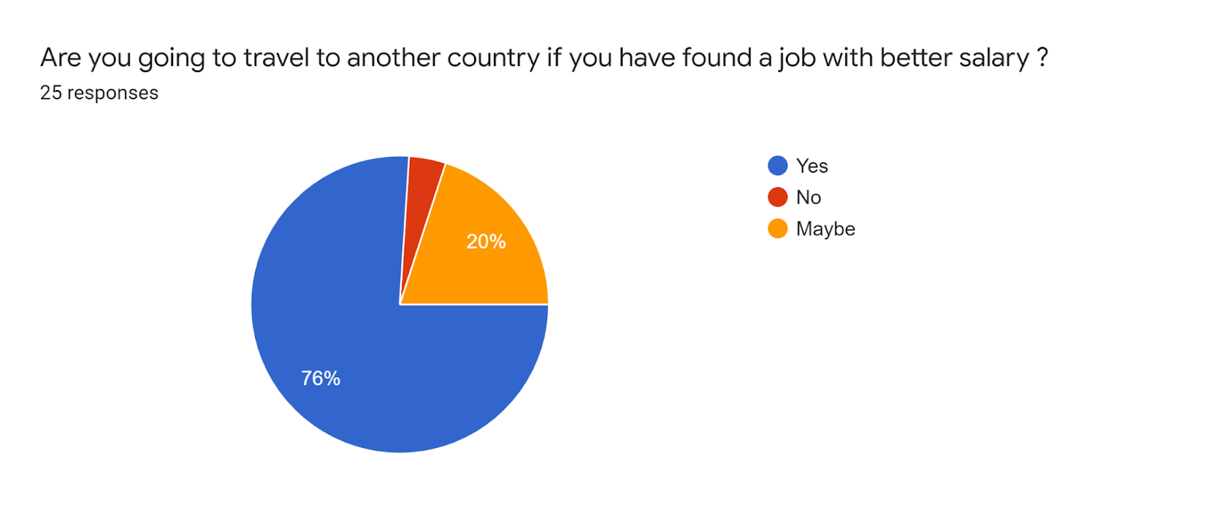

76% of students are ready to travel to other countries if they've got better income opportunities, while 20% said maybe meaning they are not sure, and 4% said no. The results show that majority of informants are ready to immigrate for a better work condition, which is a factor that influences the language shift of members of a society.

Language shift can happen in a society as a result of socioeconomic factors, which encourage members of a society to learn the more prestigious language in a business, in this situation English is the more prestigious language in the field of computer science.(Part1 chapter1section 2).

**Question 8: What language do you prefer to learn new technologies with and for tutorials online?**

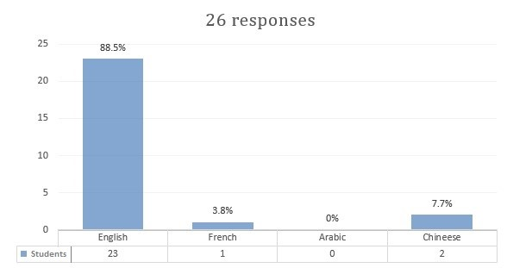

These results show that 88.5% use English language when studying new computer science materials, while 7.7% said Chinese and 3.8% use French. We can say that mostly all students prefer English as their language to read about technologies and materials of computer science. This result may show that English is the dominant language in computer technology which students find easy to use, compared to other languages like French or Arabic which are official languages in Morocco even though they are both used in Academic fields. We can state that English is preferred by students because most online tutorials and documentation about computer science are written in English by both native and nonnative speakers, in addition, English is the language of communication between people in this field which is like a linugua franca for them.

**Question 8: Do you need good communication skills to work in another country like USA, UK or Canada?**

According to these results, 80.8% of students agree that effective communication skills are required for work in other developed countries like USA Canada, and UK, while 19.2% of student says maybe, none of the students disagree. It is clear that most of students are aware of the importance of effective communication skills in the market.

**Question 9: Are you ready to take a Language test certificate Like IELTS or TOEFL to work outside your country?**

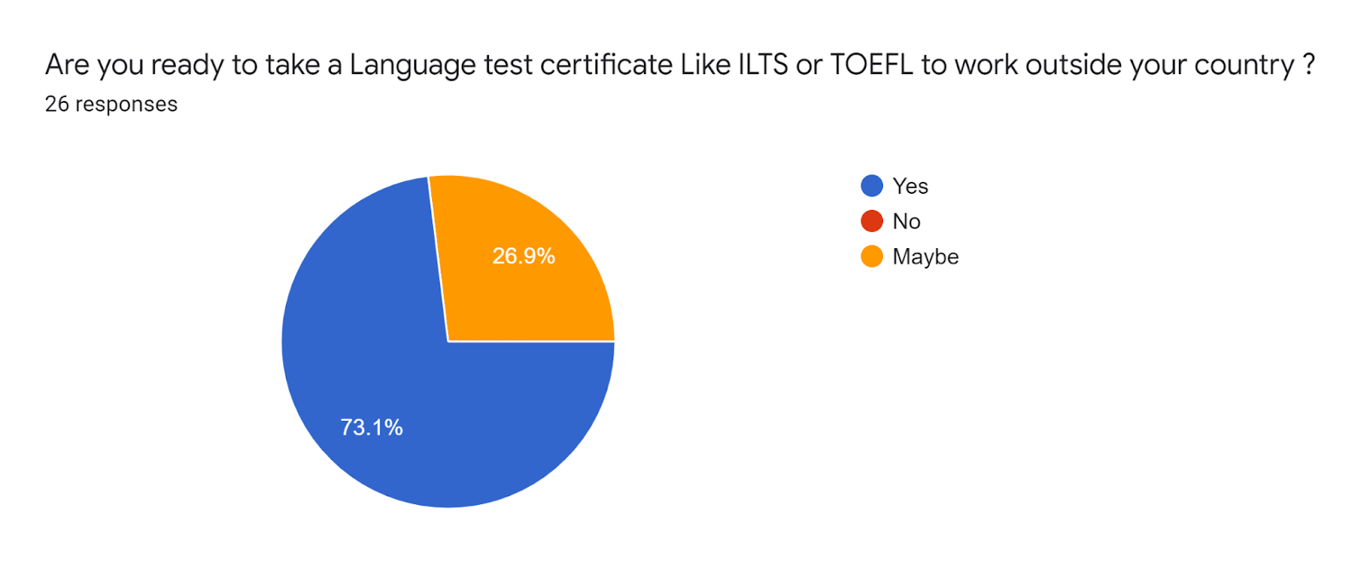

The result shows that 73% students are ready to get a language certification if required for work, like IELTS English Language Testing System or TOEFL Test of English as a Foreign Language, while 26.9% students said maybe. Now we can say that most of informants can prepare for English language certifications, which will make them enhance their skills and interest in English.

**Question 10: if you are going to continue your study after graduation what language do you like to study with?**

According to these results, 92% of students have chosen English as their language of education if they want to extend their studies, while 7.7% prefer French. We can assume English is the dominant language and the majority of students will focus more on English rather than other languages.

**Question 11: Knowing good English grammar is important for effective communication when working on IT**

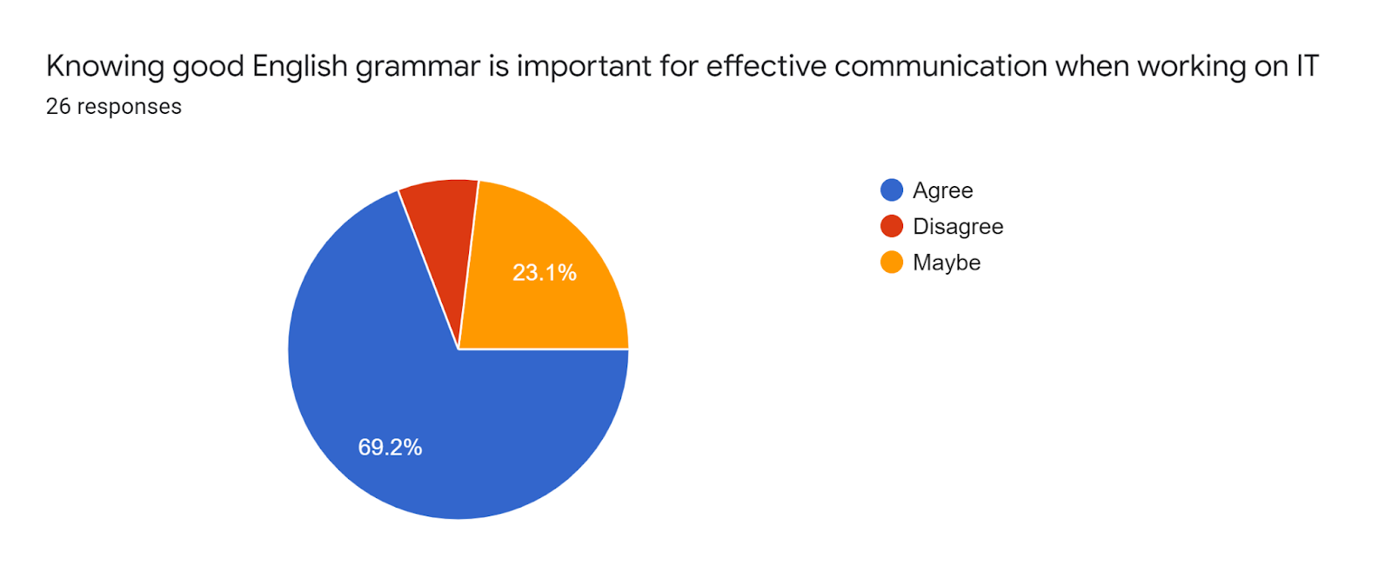

The results show that 69.2% agree that knowing good grammar is important for communication with people when working in IT or in computer science fields. 23.1% said maybe, while only 7.7% disagree. We can assume that students are concerned with grammar skills and probably they will improve theirs because of the need for communication within a work or study environment. English grammar is important for computer science students because many tasks require forming correct language, for instance when reading documentation, asking questions, searching for technical errors solutions, or when learning about new technologies, as well as when talking with people that speak different languages in the work space or at school.

**Question 12: Are you going to develop your English skills to be able to read non translated documentation and articles related to IT?**

According to the result 100% of students are willing to work on their English language skills so that they can read English resources and documentation that they need in their information technology or computer science positions, while 0% of students disagree. Now we can say that all informants are aware of how valuable it is for them to enhance their English language skills level. This means that computer science can influencing the learning desire of students or professionals within the field of IT and computer science.

**2.3 Findings**

This section describes the findings extracted from data analysis concerning the influence of computer science on students language change and shift that is related to learning the English language. From the above-mentioned results, we can see that:

* Majority of students are studying or learning computer technologies by themselves.
* Half of the students are engaged in a formal education program for computer science and the other half learn by themselves online.
* All students agree that English language skills are necessary to work as a computer programmer.
* Most of students admit that English language is vital for a successful career in IT.
* Majority of informants use English for computer error debugging or when they search for errors solution online.
* Most of the students believe that studying information technology or computer science helps them learn new vocabulary.
* Half of the students are more interested in computer programming and the rest are interested in fields like computer graphics, networking, and system administration.
* Half of the informants admit that the English language is a requirement for better salaries in the IT market.
* Majority of students are ready to immigrate for improving their financial and social status.
* Nearly all students use English for learning new technologies and for reading technical documentations of computer science.
* The majority of students are aware of the importance of having good communications skills in English-speaking countries.
* The majority of students are going to take a language test certificate like IELTS or TOEFL if it's required for work or study outside Morocco.
* Nearly all informants will choose English if they want to extend their studies abroad.
* All students will improve their English language skills to access more technical resources and documentation about computer science and information technology.

From all the above findings, we can assume that students of computer science are expected to have a shift and or a change in their language, meaning they will have more use of English as a result of its dominance in the field of computer science. Students will improve their language in all dimensions so that they can succeed in computer science and information technology. "Education and occupation are social factors that can motivate individuals to change their language as well as economic factors which means individuals within a community are supposed to move to a work environment where they have to speak a certain language that is more prestigious or dominant within a business class"(Part1, Section 1.2). This concludes that many computer science students and professionals are highly expected to experience a change in their language because of the effect of education and occupation factors.

Works Cited

**Bibliography:**

Abbas, Jasim Mohammed. "The Impact of Technology on Modern English Language." Al-Iraqia University–College of Arts (2019).

Al Amadidhi, Darwish. "Economy as a factor in language change." (1990), pp. 7-27.

Salikoko, Sangol. Mufwene. “Language Shift - International Encyclopedia of Linguistic Anthropology - Final Revisions.” University of Chicago 2018.  
 [https://www.researchgate.net/publication/328027240](https://www.researchgate.net/publication/328027240_LANGUAGE_SHIFTINTERNATIONAL_ENCYCLOPEDIA_OF_LINGUISTIC_ANTHROPOLOGY_-_FINAL_REVISIONS)

Beaubouef, Theresa. "Why computer science students need language." ACM SIGCSE Bulletin 35.4 (2003): 51-54.

Lee, Konsbruck Robert. "Impacts of Information Technology on Society in the new Century." Business and Management 5.6 (2002): 46-55.

Panagiotidis, Panagiotis, et al. "Technology as a motivational factor in foreign language learning." European Journal of Education 1.3 (2018): 43-52.

Sri Lestari and Radius Setiyawan. ‘Technology Era, Global English, CLIL: Influence and its Impact on English Teaching for Young Learners in Indonesia.“ IOP Conference Series: Earth and Environmental Science, vol. 469, no. 012094, Apr 2022, pp. 1-8,   
 <https://iopscience.iop.org/article/10.1088/1755-1315/469/1/012094>

**Webliography:**

“8 Reasons to Study Computer Science at University”, *DePaul University* 01 June 2021, 29 Apr 2022.  
 [https://globalgateway.depaul.edu/blog/8-reasons-to-study-computer-science-at- university](https://globalgateway.depaul.edu/blog/8-reasons-to-study-computer-science-at-%09university)

Collom, Katie. “Can Economic Development Affect Language?.” *Language Trainers* 19 Aug 2020, 28 Apr 2022.  
 https://www.languagetrainers.com/blog/can-economic-development-affect- language/

“Communication Skills for Computer Science Students.” *Computer Sience Teachers Association,* 13 Apr 2009, 27 Apr 2022. [http://advocate.csteachers.org/2009/04/13/communication-skills-for-computer- science-students/](http://advocate.csteachers.org/2009/04/13/communication-skills-for-computer-%09science-students/)

“Computer Science vs. Information Technology: Careers, Degrees, and More.” *Coursera*, 15 Dec. 2021, 24 Apr 2022.

[www.coursera.org/articles/computer-science-vs-information-technology](http://www.coursera.org/articles/computer-science-vs-information-technology).

David, Maya. Khelmani. “Language Maintenance, Language shift, & Language Revitalisation - A Lecture by Prof. Maya David @CU.”, Youtube Uploaded by C U Linguistics, 26 Jan 2021. 12/04/2022.  
 <https://www.youtube.com/watch?v=OxNPlwPaxlw>

“Do I Need To Speak And Understand English Software Engineer.” *YouTube,* Uploaded by Amigoscode, 18 May 2020, 27 Apr 2022.  
 <https://www.youtube.com/watch?v=XkP6eEGAXmA>

“English As A Language of Science and Technology.” *Language Connections*, 7 Feb. 2020. 15/04/2022.  
 [www.languageconnections.com/blog/english-the-universal-language-of-science](http://www.languageconnections.com/blog/english-the-universal-language-of-science).

Jorgensen, Jayson. “Learning the Value of English as a Computer Science Major.” Reading Horizons, 13 Sep 2017, 26 Apr 2022.   
 <https://readinghorizons.website/blog/learning-the-value-of-english/>

Mandl, Jenny. “Why are all programming languages in English?” *Medium, 16 Jun 2016, 25 Apr 2022.* [https://medium.com/@jennymandl/why-are-all-programming-languages-in- english-12b1312bada4](https://medium.com/@jennymandl/why-are-all-programming-languages-in-%09english-12b1312bada4)

Mplewis. “Migration and Language Contact.”, *Ethnologue*, 1 Oct. 2015. 10/04/2022.

[https://www.ethnologue.com/ethnoblog/m-paul-lewis/migration-and-language- contact](https://www.ethnologue.com/ethnoblog/m-paul-lewis/migration-and-language-%09contact)

Nikhil, Sonnad. “Tim Cook doesn’t seem to understand that good programmers have to learn English.” *Quartz*, 12 Oct 2017, 07/04/2022

<https://qz.com/1101096/>

“Non-English-based programming languages”, *Wikipedia,* 04 Apr 2022, 23, Apr 2022.  
 <https://en.wikipedia.org/wiki/Non-English-based_programming_languages>

Nyabol, Nanjala. “What Will Be the Language of Our Digital Future?” *The nation, 15 jul 2021, 26 Apr 2022.* <https://www.thenation.com/article/society/digital-rights-language-technology/>

Sharf, Samantha. “The World's Largest Tech Companies 2016: Apple Bests Samsung, Microsoft, And Alphabet”, *Forbes,* 26 May 2016, 24, April 2022.  
 [https://www.forbes.com/sites/samanthasharf/2016/05/26/the-worlds-largest-tech  
 companies-2016-apple-bests-samsung-microsoft-and-alphabet/](https://www.forbes.com/sites/samanthasharf/2016/05/26/the-worlds-largest-tech%09companies-2016-apple-bests-samsung-microsoft-and-alphabet/)

Sreeraman Thiagarajan, “Why English is now an increasing prerequisite to enter technology driven global markets.” *The Economic Times,* 14 Nov 2017, 29 Apr 2022.  
 [https://economictimes.indiatimes.com/small-biz/security-tech/technology/why-english-is- now-an-increasing-prerequisite-to-enter-technology-driven-global- markets/articleshow/61639802.cms](https://economictimes.indiatimes.com/small-biz/security-tech/technology/why-english-is-now-an-increasing-prerequisite-to-enter-technology-driven-global-markets/articleshow/61639802.cms)

“What is Information Technology about and its growth by 2025”, *LNCT* 25 May, 2021, 26 April 2022.  
 <https://lnct.ac.in/what-is-information-technology-about/>

Yuen, Vanessa. “Programming 101: Learn English.” *YouTube,* Uploaded by EmpireJS, 24 Oct 2017, 27 Apr 2022.  
 <https://www.youtube.com/watch?v=pOwnBPaW5zE&t=3s>

**[Presentation point]**

- My project is about language change and shift.

- Socioeconomic factors and education need can change students language.

- Students of computer science can have shift in their language because of the dominance of English language in computer science and information technology.

- Language change can happen gradually and in this scenario the socioeconomic factors are the major factor in students language change.

- This supports the hypothesis that computer science can influence language shift and change of student and professional of computer science and information technology.